**WORK AND OFFICE VOCABULARY**

September, 19th, 2020 Ph Update: 13 Jan 2024 Nguyen V10

**>Responsibilities**

* What do you do **for a living**? To **earn a living**? What does your job **consist in**? What is your **occupation**?
* **I’m responsible for** updating the company website / **I’m in charge of** interviewing candidates for jobs.
* **My job involves** giving tours of the museum. /**Within the frame** of my job, I speak Japanese
* My job **consists in** designing new models
* Decomposition: My Department **consists of** three teams, one specialized in accountancy, the other one in finance, the third one in strategy.

**>My company & Firm**

* CDD/CDI: I work **at** (a company) on **a permanent** contract (=unlimited-term contract) / **temporary** contract (=fixed-term contract)
* I work **for** (a company / a person)
* I work **in** (a place, city, country, department, or general area/industry)
* I work **with** (people / things)

**>Unemployed**

* I’m **unemployed =** I’m **out of work =** I’m **between jobs** at the moment.
* I’m **looking for** (a position/ opportunities). I have to **take/sit job interviews** to get a job.
* I’m **on the dole** (receiving money because of unemployment situation)

**>If you’re good at your job**, you might get a **pay rise** (or a **raise**) – an increase **in** your salary (**by** 10%/$1000)- **perks** (a car at your disposal, …)

**>To resign**

* I’m going to **quit my job=** I’m going to **leave my job.**
* I go on **maternity leave**/ I go on **sick leave**
* I retired in 2013, now in 2018, I am retired, I am a **retiree**
* Délai de préavis: He has to work for a **two-month notice period** in his former company
* Période d’essai: He’s about to pass his 6-month **probation period/ trial period** and then turn afterwards to be a permanent employee

**>To be fired/ To be made redundant/ to be dismissed/ to be laid off/ to be sacked**

**>To turn down an offer (not to accept the job)**

**> Time:**

* we typically use the expression **go to work** for arriving at work, and **get off work** for leaving work. For example, I go to work at 8:30, and I get off work at 5PM
* You can work **full-time** (usually about 40 hours per week) or **part-time** (usually 15-25 hours per week). A small number of companies offer **flex-time,** meaning the employee can set his/her own schedule.
* In some jobs, you work **shifts** meaning the hours are not the same every day; instead, you work a specific block of hours that the manager schedules. If you work **overtime,** it means you **work extra hours** in addition to your normal schedule.

**>Status**

* **Apprentice** – a person who learns a job or skill by working for a fixed period of time for someone who is very good at that job or skill.
* **Trainee** – a person who is being trained for a job. He does **training** or an **internship**.
* When you’re **hired** (=**recruited/enrolled**), you become an **employee**of the company. The company becomes your **employer.**The other **employees** in the company are your **colleagues, teammates**or **coworkers.**The person above you who is responsible for your work is your **boss, manager** or **supervisor.**

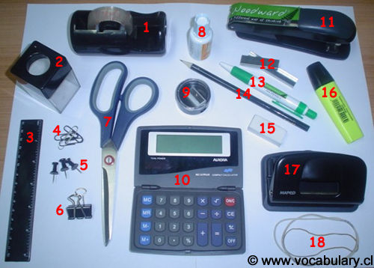

**>Office tools**

|  |  |  |
| --- | --- | --- |
| 1-Tape (dispenser)  2-Paper clip holder  3-Ruler  4-Paper clips  5-Pushpins  6- Bulldog clip | 7-Scissors  8-Correction Fluid (white-out)  9-Pencil sharpener  10-Calculator  11-Stapler  12-Staples | 13-Pen  14-Pencil  15-Eraser (= rubber)  16-Highlighter  17-Hole-punch  18-Rubber bands (elastic bands) |

**>Engagement**

* I work ON the study
* I collaborated (WITH a German partner) ON the experiments
* I participate IN the project / I am engaged IN the new projects
* I invest IN the sustainable energy sector
* An involvement IN the emerging sector
* You contributed TO the success of your company/ Thanks for your contribution TO the reliability of the system
* A commitment TO helping unprivileged people/ A commitment TO the battle against diseases
* I subscribe TO the upcoming session (to with event or service)/ I subscribe for new Companies shares, for alternative ideas